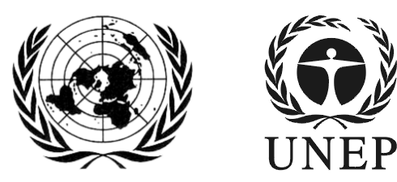 | SAICM/ICCM.5/Bureau.2/INF/2
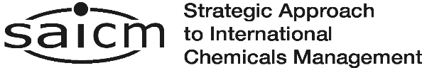 |  | Distr.: General  22 November 2016  English only
Second meeting of the Bureau of the
International Conference on Chemicals Management for its fifth session
Sao Paulo, Brazil
7 - 8 December 2016
Item 6 (e) of the provisional agenda*
Implementation towards the achievement of the 2020 goal: Other

Status of funding of SAICM activities July 2012 to November 2016

Note by the secretariat
The secretariat has the honour to circulate in the annex to the present note, the status of donor contributions to the SAICM secretariat from July 2012 to November 2016.

Donor contributions to the Strategic Approach July 2012 – September 2016
(United States dollars)
Contributions deposited | July to December 2012 | 2013 | 2014 | 2015 | 2016 | Total
Austria |  |  | 27 210 | 10 893 |  | 38 103
Belgium |  | 26 525 | 25 412 | 21 786 | 21 786 | 95 509
Benin |  |  |  | 8 303 |  | 8 303
Denmark | 33 647 | 44 823 | 134 005 | 62 792 |  | 275 267
European Union | 655 000 | 338 000 |  | 544 662 | 546 182 | 2 083 854
Finland | 12 953 | 13 587 | 39 526 | 40 305 | 41 105 | 147 176
Germany | 65 054 | 120 960 | 276 833 | 216 775 | 162 309 | 841 931
Guyana |  |  | 500 | 1 000 |  | 1 500
Kenya |  |  | 5 000 |  |  | 5 000
Netherlands |  | 67 843 | 65 876 | 54 466 | 55 996 | 244 181
Norway | 120 291 | 149 071 | 112 410 | 38 212 | 39 162 | 459 146
Pakistan |  |  | 2 000 |  |  | 2 000
Slovenia | 3 861 | 3 831 | 4 149 | 3 267 | 3 268 | 18 376
Sweden | 221 720 | 207 468 | 302 623 | 41 143 | 89 268 | 862 222
Switzerland | 21 790 | 12 070 | 237 451 | 345 830 |  | 617 141
United States of America | 400 000 | 370 000 | 370 000 |  | 300 000 | 1 440 000
UNEP |  | 139 400 | 280 000 | 50 000 |  | 469 400
International Council of Chemical Associations |  |  | 135 000 | 135 000 |  | 270 000
Total | 1 534 316 | 1 493 578 | 2 017 995 | 1 574 434 | 1 259 086 | 7 879 409

*SAICM/ICCM.5/Bureau.2/1

